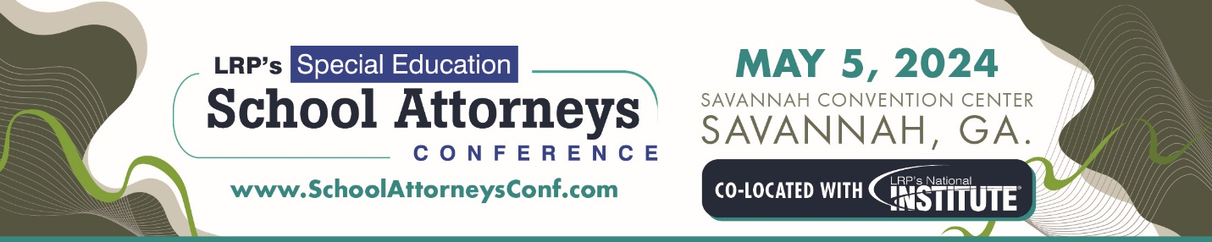

Event: LRP’s Special Education School Attorneys Conference
Location: Savannah Convention Center, Savannah, Ga.
Date: May 5, 2024

The Special Education School Attorneys Conference seeks to offer a content-rich program full of tools and techniques used when representing school districts in special education matters. The conference with its nationally recognized speakers continues to be a must for all school attorneys.

Attendees must be attorneys who do not currently represent parties with special education interests adverse to school districts. These criteria apply only to the individual attorney and not to other attorneys in the registrant's firm or attorneys with whom the registrant may be associated. The audience ranges from entry level practitioners to highly experienced and advanced individuals in the legal profession.

We are looking for presentation proposals to speak at the Annual Special Education School Attorneys Conference. Significant decisions, new regulations, strategies for improvement, innovative approaches to due process and civil proceedings, and discussions of specific legal issues are all topics of interest to the conference’s audience, which has a strong understanding of special education laws. All sessions must include specific strategies for attendees.

The promotion or endorsement of particular products or companies is strictly prohibited.

We prefer only one speaker per session. Only RFP submissions by a single presenter will be reviewed and accepted.

In 2024, the Annual Special Education School Attorneys Conference will be held in conjunction with LRP's National Institute on Legal Issues of Educating Individuals with Disabilities®. With these co-located events, attendees have the opportunity to double their learning and networking opportunities. RFPs submitted for the School Attorneys Conference should be tailored to school attorneys and should not duplicate RPFs submitted for the National Institute.
Types of sessions and requirements:

In-depth session (90 minutes)
Breakout Session (60 minutes)
Ethics (60 minutes)

If you have any questions or problems submitting this form to LRP’s School Attorneys Dropbox, please contact Conference Chair Julie J. Kline, Esq. at 561-622-6520, ext. 8723, or jkline@lrp.com.
Return this completed application by June 26, 2023 to LRP’s School Attorneys Dropbox – CLICK HERE TO SUBMIT.

Questions submitter must answer:

1. Presentation Agreement: If this proposal is accepted by LRP’s Annual Special Education School Attorneys Conference, presenters must guarantee that he/she is the sole proprietor of this material and content, and that no proprietary rights or copyrights belonging to any other person or party exist. They further agree to deliver in advance to the conference the proposed session materials (.PPT is required; written outline is encouraged). I have read and agree with these terms.
__ I Agree
__ I do not agree

2. Is submitter the same as presenter?
__ Yes
__ No

3. Focus Area
__ Discipline/Behavior
__ Ethics
__ FERPA
__ IDEA
__ Mediation/Resolution
__ Litigation Preparation
__ Section 504
__ Other: _______________________________

4. Presentation Type
__ In-depth Session (90 minutes)
__ Breakout Session (60 minutes)
__ 1-hour Ethics (60 minutes)

5. What is the experience level of the intended audience?
___ Basic
____Intermediate
___ Advance

6. Presenter is a prior attendee of LRP’s Special Education School Attorneys Conference?
__ Yes
__ No

7. Presenter has prior public speaking experience with LRP Media Group?
__ Yes Conference or event: ________________________________________
__ No If your answer is no, attach video clip or link, or audio file of prior presentation for further consideration.

8. Has speaker or law firm members presented this same session at another conference, webinar, or symposium, or will speaker or law firm members give the same presentation at another conference or webinar within 60 days of the 2024 School Attorneys Conference?
__ Yes Name and date of conference or event: ________________________________
__ No

9. Will presenter attend other sessions other than his/her own at the School Attorneys Conference?
__ Yes
__ No

10. Are you a subscriber to Special Ed Connection?
___ Yes
___ No

Session Specifics

Descriptive Session Title to Appear in Conference Brochure:

Short Session Description to be used in online conference brochure. (200 words max)

Presenter’s Bio to appear on conference website : (150 words max)

Three Session Learning Objectives/Take Aways for Attendees (different from session description above): For example, "attendees receive a sample policy" or "attendees will they receive five litigation strategies"

1.

2.

3.

Two cases/decisions you plan to include in your materials:
1.
2.

Submit jpeg photo to be used in online brochure:

